Design a 13x13 matrix poker strategy range view control.

The control will be passed in an IEnumerable<HandStrategyModel> which will be ordered, with AA being the first element and 22 being the last

so you can simply enumerate the collection to fill in the matrix.

public record HandStrategyModel(

// The name of the hand, like AA, or J9o.

string Hand,

// How often the hand is in the player's range.

double Weight,

// Each element represents the frequency for an action the user can take. Always sums to 1.

double[] Strategy,

// The colors to use for each action in the strategy.

string[] StrategyColors

)

- You should end up with a control that looks like this: 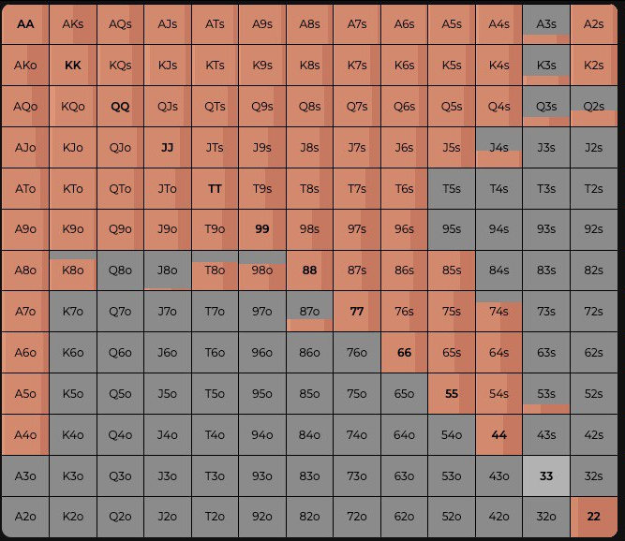

- Implement logic for When the user clicks on a hand like "Q9o". When clicked a command should be triggered with a parameter of the clicked hand (in that case "Q9o").

- Place emphasis on performance and try to make the control as reasonably performant as you can.